DONOR ENROLLMENT DAY: A DAY TO INSPIRE NEW YORKERS TO SAVE LIVES
Did you know that 8,500 New Yorkers are currently waiting for a lifesaving organ transplant, and thousands of others are in need of healing tissue and cornea transplants? These are our friends, family, and neighbors and they need our help. October 7th is Donor Enrollment Day, a day focused on creating awareness of the power of registering as an organ, eye, and tissue donor.

Currently, New York has a shortage of donated organs, which means those in need wait for a long time, often five years or more, before receiving the transplant they need to save their lives. Many people can’t wait that long – last year, more than 600 New Yorkers died because the organ they needed to save their life was not donated in time. We can restore hope to those who wait by enrolling in the New York State Donate Life Registry.

Here are some things to keep in mind:
- One organ donor can save eight lives, and heal seventy-five more through eye and tissue donation.
- All major religions support organ, eye and tissue donation, viewing it as an act of love and generosity.
- No one is too old or too sick to register an organ, eye, or tissue donor - Doctors conduct thorough medical evaluations of potential donors to ensure donated organs and tissues are safe for transplant.
- Registering as a donor does not affect your medical care. Doctors and medical staff are legally obligated to save your life, and donation only becomes an option after death has been determined.

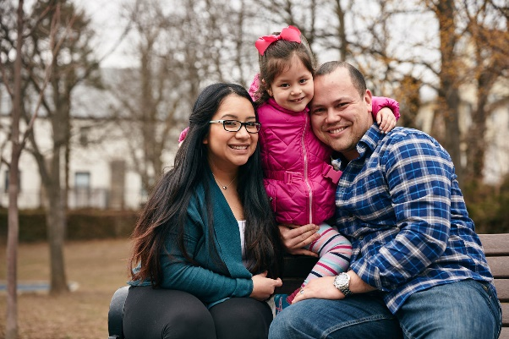 | Lauren was added to the heart transplant waitlist in 2016 - five years has passed, and she is still waiting. Each day the list of things she can no longer do with her family continues to grow. Yet, she remains resilient and strong in her fight for her family, and most of all for her young daughter Sophia. Register as an organ and tissue donor at [donatelife.ny.gov/register or contact Donate Life NYS to obtain unique trackable link] and bring hope to the thousands of New Yorkers just like Lauren waiting for lifesaving and healing organ, eye, and tissue transplants.

